Topic 2:

**Design of Smart Home Usage scenarios**

# Idea:

* The Smart Home Demo Lab will have a central controller that coordinates multiple of ecosystems, within multiple different devices ranging across different device categories work and can interact together.
* The Demo Lab Controller will be able to “play” certain scenarios (and attacks on them).
  + This includes device configuration, data recording, …
* Your goal is to **design a system that can store different scenarios and can manage/coordinate their order of events**
* To achieve this goal, the Demo Lab Controller (the system you design) will speak with the individual ecosystem controllers.
  + Each ecosystem has at least one central ecosystem controller
  + The ecosystem controller receives signals and information from the devices e.g. temperature readings, but also battery status etc.

# Requirements:

* System can interact with both Smart Home Devices as well as technical tools like a raspberry pi
  + RPI acts e.g. as an attacker and as an network tap
  + Send commands to individual devices using the ecosystems controller (API!) [this may include configuration etc.]
* Record data during scenario
  + Goal: PCAP files
  + Record e.g. network traffic, sensor values, etc.
* Documentation on each of your scenarios:
  + Involved device categories
  + Expected data traffic/size
  + Duration
  + Number of required people
  + Notable Things (e.g. Architectures,…)
  + Used protocols
  + Which ecosystem supports this scenario?
  + Possible attacks on this scenario
  + Who is the attacker?
  + Who is the scenario controller?
  + Information about data privacy
    - Which data is recorded? Is it sensitive?
  + Description of the order of events
    - What happens when? What are the individual steps?
    - Both natural language and technical process (separate!)
  + Setup / Run Script

# Already done:

* List of devices (name, supported protocols, natively supported software) <https://box.fu-berlin.de/s/XaJYfdXbXRzm9AW>
* Ideas for usage scenarios
  + “normal usage” of SH
  + People moving across Rooms
  + No one present at home
  + Lights flickering
* First sketch for possible design and supported ecosystems
* Home Assistant (and its extensions) should be used as the foundation of the Demo Lab Controller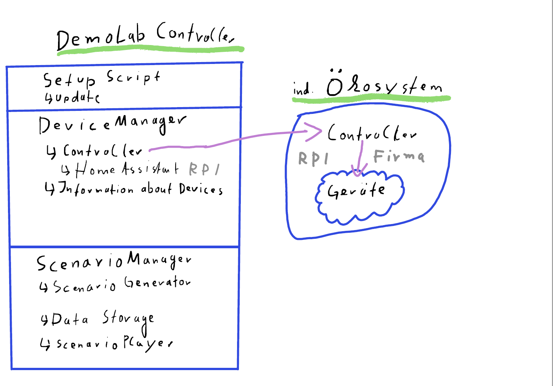

# To do:

* Decide on a scenario API
  + JSON script that a program can read and translate into commands?
* Create a test ecosystem
  + Setup devices,
  + setup software,
  + setup RPI, etc.

# Addons:

* + Scenario Generator